Data Science Documentation

Contents

GitHub 1

R Programming 1

Loops 1

# GitHub

**Getting started, first step to clone repository and sync files to new directory:**

1. cd <directory> (change the desired location to clone your repository)

2. git clone <url> (example: git clone https://github.com/JamesNacino/datasciencecoursera.git)

**Steps for syncing your directory to online repository:**

1. cd <directory> (This directory should be the one that you have cloned from the repo)

2. Save your new file into the directory (the directory with the same name as your repo)

3. git status (optional: to check which files have or haven't been committed)

4. git add <file name> (add any new files to directory by file name)

5. git commit -m "added <file name>" (lock file into repository)

6. git push (sync file(s) to online repository)

# R Programming

## Loops

Example) Finding the mean of a column, given a selected item in another column. Here, ‘Iris’, is the name of the data frame

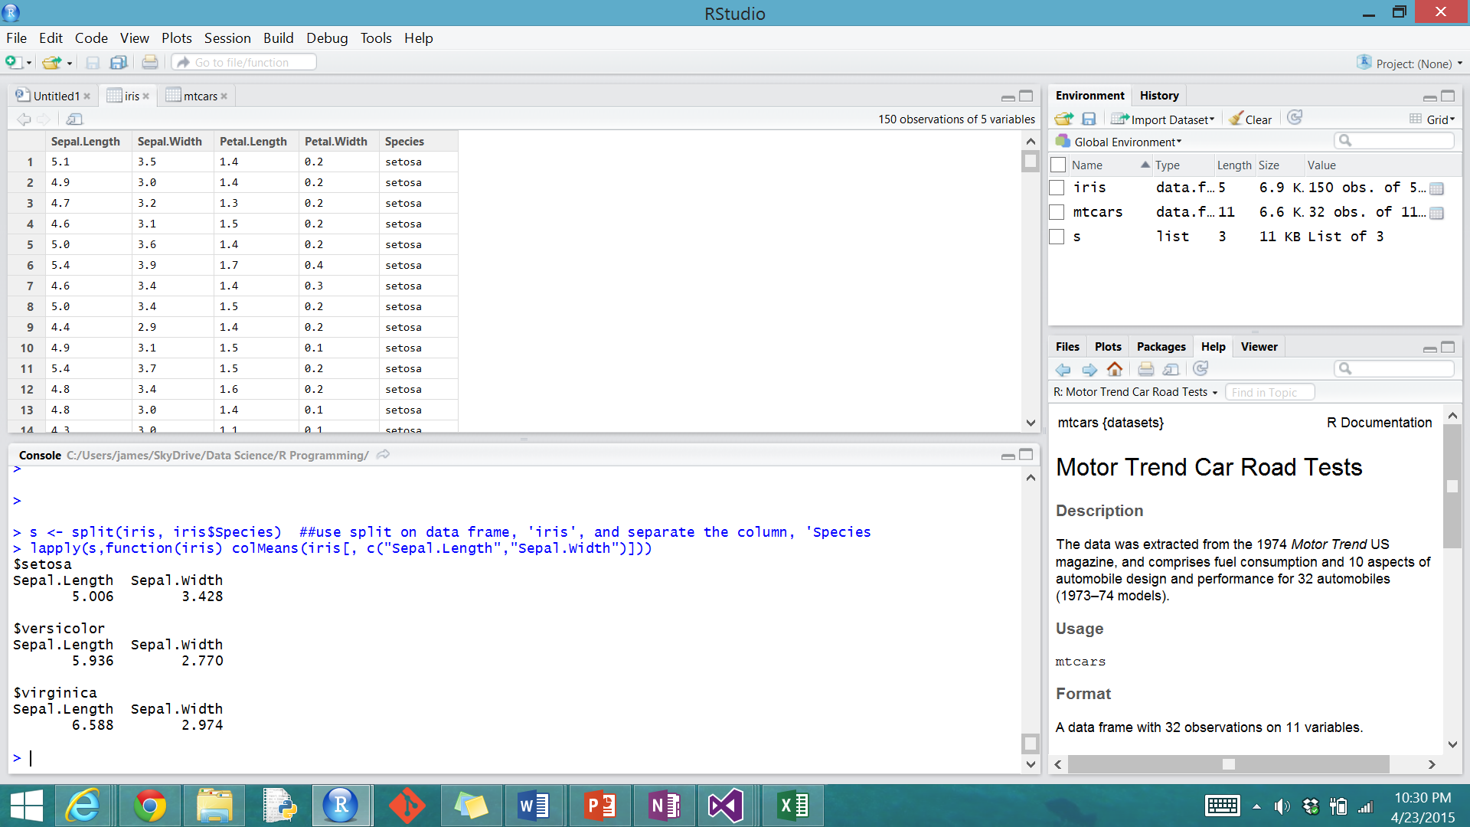

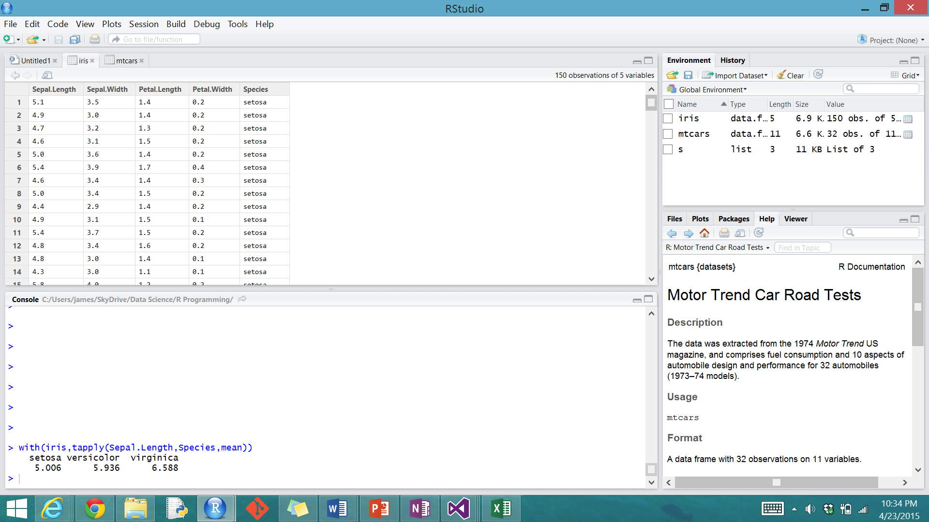

Example) Finding the mean of each column in a data frame. Also finding the mean of specific columns in a data frame. Here the data frame is named ‘mtcars’. In the comment in the code, use ‘1’ instead of ‘2’, to preserve the rows

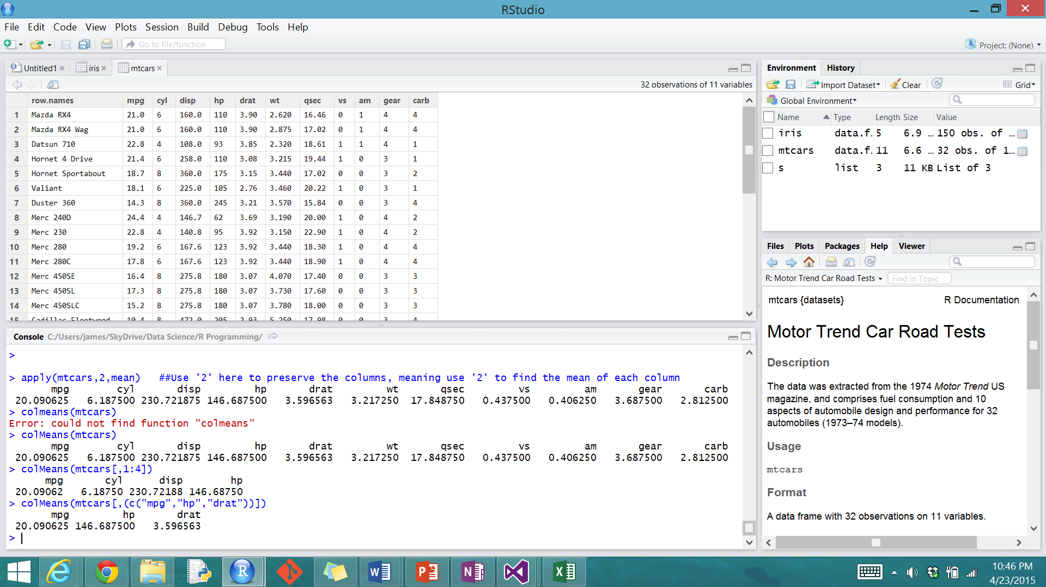

# Getting and Cleaning Data